

PRODUCT SPECIFICATION SHEET

LARGE CAPACITY SOAP DISPENSER

KHP PART No: SPD WOP UNP

DESCRIPTION

- Designed for use with the 2.5-litre cartridge.
- SOAP OPTIONS
  - Apricot Industrial cleanser with scrubbing particles (SOP ABR)
  - Regular soap (SOP SAV REG LRG)
- DISPENSING
  - Apricot industrial cleanser 1.5 ml
  - Regular soap 1.0ml.
- Supplied with reusable soap nozzle. (NOZ SPD ABR IND)
- Available as a Direct fill option.
- Large window showing soap level.
- Large “PUSH TO DISPENSE” Knob for ease of use.
- Self-locking cover, sharing common key with other range products.

DIMENSIONS
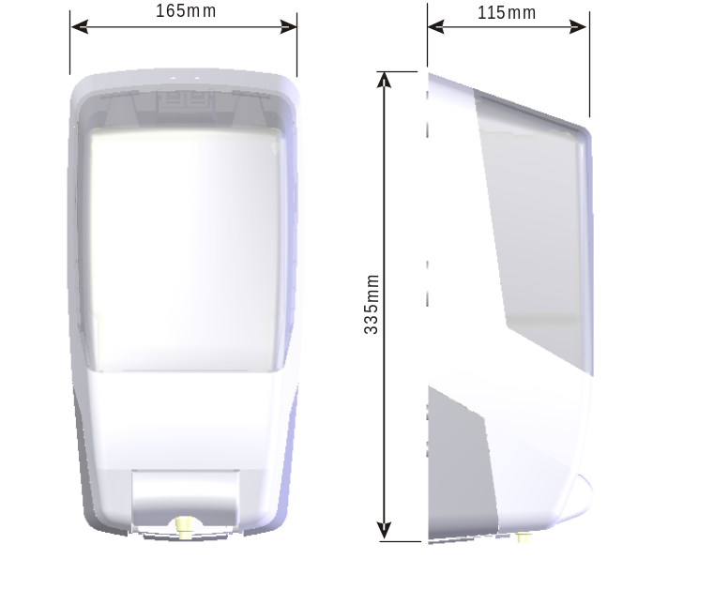

MATERIALS

Dispenser constructed from ABS, pump assembly from engineering thermoplastics. Dispenser and pump can be recycled in accordance with local regulations.

PACKAGING

Packed in quantities of 12 Dispensers.
Cartons Size. 680mm x 570mm x 245mm.Total weight: 10kg.
Dispenser weight (without consumable) 720 grams

