

PRODUCT SPECIFICATION SHEET

SIGMA ELLIPSE TISSUE DISPENSER

KHP PART No: TSD SIG ELP

DESCRIPTION

- Accepts range of readily available toilet rolls up to 140mm O/D and 115mm depth.
- Accepts core diameters from 28 to 46mm.
- Window provides clear viewing of the rolls to aid servicing of the unit.
- Roll held on braked mandrel, giving smooth controlled operation
- Cutting teeth around bottom edge assists with tearing of paper.
- Dispenser can be sited on left or right hand side of cubical.
- Dampened opening of hinged cover.
- Tray prevents premature use of full roll.
- Tray returns to start position automatically when the cover is opened.
- Replaceable front insert.

DIMENSIONS
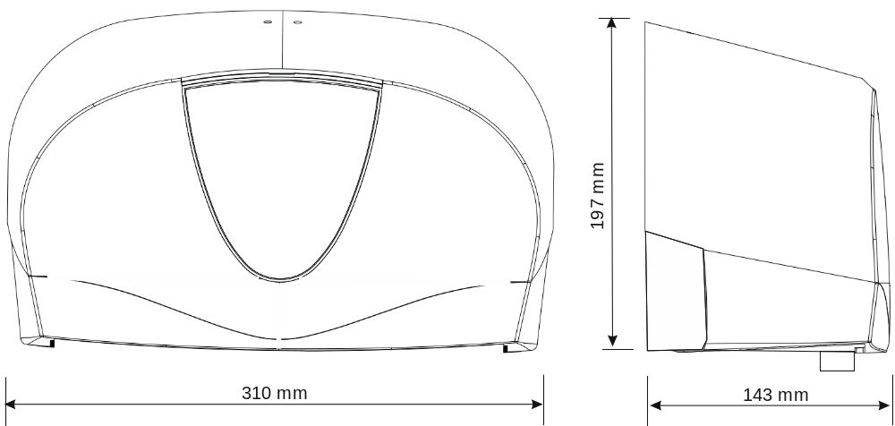

MATERIALS

Constructed from ABS and other engineering thermoplastics. Dispenser can be recycled or disposed of in accordance with local regulations.

PACKING

Individual units packed in polybags with cardboard in between them..
Individual weight: 770 gms
4 units packed into carton: 600mm x 315mm x 205mm
Total weight: 4.3 Kg


